Various Insect Defoliators
Medium to Low priority
Species Affected | Foliar Disease
Bl, Sx | 2-Year-Cyle Budworm (Choristoneura biennis) IDB
Hw, True Firs, (Ss) | Western blackheaded budworm (Acleris gloverana) IDH
Hw (& all other species) | Western hemlock looper (Lambdina fiscellaria lugubrosa) IDL
Hw, Ba, (Sx, Fdi) | Hemlock Sawfly (Neodiprion tsugae) IEB
Deciduous species | Forest tent caterpillars (Malacosoma californicum pluviale) IDF
Paper birch | Birch leaf miner (Fenusa pussila) IDN

Description

Affecting Conifer Species

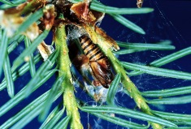
The 2-year-cycle budworm takes two years to complete its life cycle, with eggs laid primarily in even-numbered years. Larvae prefer current foliage but will feed on older foliage if current foliage is depleted. The second spring damage is the heaviest. The crowns of damaged trees appear reddish-brown from June to September. The initial symptoms of defoliation may be seen in tree tops and branch tips, where chewed needles accumulate in webbing. Tree mortality can occur after several successive years of severe defoliation, particularly on immature or suppressed trees. Other damage includes top-kill (resulting in stem defects), reduced seed production due to damaged cones, and height and volume loss.

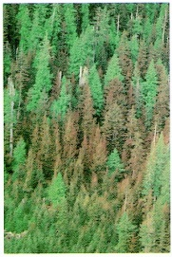
The western blackheaded budworm prefers current foliage, but older needles will be attacked during heavy infestations. From a distance, the damaged stand has a reddish-brown hue. The western blackheaded budworm prefers to feed on the upper crowns of dominant and codominant trees. Trees can be completely defoliated from a heavy attack. This severe defoliation can result in growth reduction and predisposition to attacks from secondary organisms. Successive years of severe defoliation may result in tree mortality. Some second-growth hemlock stands that have been severely defoliated for two successive years have sustained greater than 10% mortality; 75% of the remaining trees have suffered an average of 8 m of top-kill.

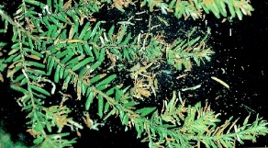
Western hemlock looper larvae feed on foliage of any age and are dispersed throughout the crown. Partially chewed needles accumulate below an attacked tree, and silk webbing is found throughout the crown. The crowns of heavily attacked trees turn yellowish-red at first and eventually reddish-brown. Defoliation occurs most commonly on western hemlock leading sites located in valley bottoms, and is often found in distinctive elevational bands. Western hemlock in the interior is intolerant of defoliation; thus, mortality can occur following only one year of heavy defoliation and may continue for up to four years after the collapse of a western hemlock looper infestation. The wasteful feeding habit of this insect greatly increases the amount of damage relative to most other defoliators. Older hemlock, amabilis fir, and Sitka spruce are most vulnerable to damage, while young Douglas-fir appears to suffer more than older. Outbreaks generally last for three years.

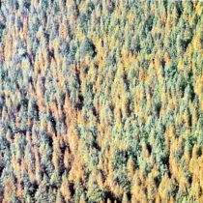
Hemlock sawfly larvae usually affect older foliage only. Mortality is not common but some top-kill and radial growth loss may occur. The potential for mortality is greatly increased by repeated defoliation, or when hemlock sawfly occurs with defoliators that prefer current foliage, such as western blackheaded budworm. Conifer sawfly damage may predispose trees to secondary attacks by other insects or fungi. Outbreaks are usually short-lived.

Affecting Deciduous Species

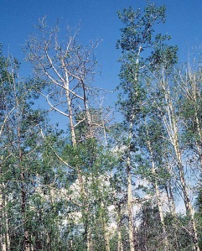
Forest Tent Caterpillar larvae feed gregariously on opening buds and on leaves. Fully grown larvae congregate on the trunk or on large branches, and will migrate to other broadleaf trees and shrubs if all the foliage is consumed. Forest tent caterpillars do not form a tent, but spin a trail of silk wherever they go. Infestations usually occur about every 10 years, and last 3 to 5 years. One or more years of severe defoliation may result in top-kill, branch mortality, reduced radial growth, and if the infestation persists, occasional mortality. Significant tree mortality has not been recorded. Severely defoliated trees usually refoliate in mid-summer.

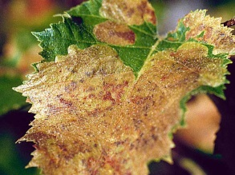
The birch leafminer is the first leafminer to attack birch in the spring. The larvae feed on the leaf tissue between the two epidermal layers. The grey/green spots on the leaves develop into brown blotches, which increase in size and eventually cover most of the leaf. Mining by these leafminers causes the leaves to dry out and turn brown. Severe damage can result in stress, slight reduction in radial growth, and branch and top die-back.

Extent
There are several defoliating insects that are considered low priority forest health factors throughout the district, and these insect populations tend to be cyclic. The losses resulting from these insect defoliators are accounted for in the current operational adjustment factors (OAF 2).
Data

Tactics
- It is important to report any defoliation as early as possible, as these outbreaks are usually of short duration, and damaged timber may be prioritized for harvest, otherwise the management tactics should conform to those tactics outlined in the outlined in the FPC Defoliator Management Guidebook. http://www.for.gov.bc.ca/tasb/legsregs/fpc/fpcguide/defoliat/defoltoc.htm
- Species diversity in plantation establishment should be encouraged.

